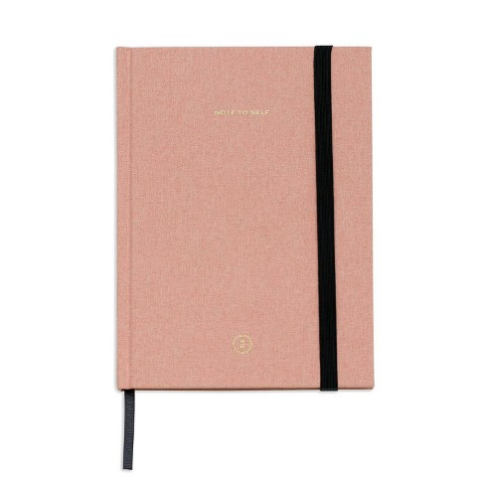

**DELIGHT LINED JOURNAL**

RYANA CALENDARS is selling wonderful lined journals! at reasonable prices. It contains beautiful and designable covers!

RS 550